**Manu by Mau**

**Overview**

This repository contains the source code for a web application built with Flask. The app is designed to create and manage children's stories, utilizing OpenAI's API for generating and moderating content.

<https://github.com/MonclerD/capstone>

**Features**

User authentication (registration and login)

Story creation with content moderation

Image generation for stories

Viewing and managing created stories

**Installation**

1. **Visual Studio Code installation**

<https://www.youtube.com/watch?v=CPmQwlycfGI>

1. **SQLite installation**

<https://www.youtube.com/watch?v=L3FwRRx6bqo>

1. **DB Browser for SQLite installation**

<https://www.youtube.com/watch?v=o8d38cGb7vY&t=282s>

1. **Python installation**

<https://www.youtube.com/watch?v=HyAleMfb5og>

1. **Git installation**

<https://www.youtube.com/watch?v=cJTXh7g-uCM>

1. **Install the required dependencies/libraries**

<https://www.youtube.com/watch?v=ENHnfQ3cBQM>  
pip install Flask

pip install Werkzeug

pip install openai

1. **Pull/Clone the GitHub repository**

<https://www.youtube.com/watch?v=ILJ4dfOL7zs>

<https://github.com/MonclerD/capstone>

**If project folder/file already downloaded/exists in your computer:**

<https://www.youtube.com/watch?v=197JAS1gNKo>

**Initial Setup**

* **Open app.py file**
* **Click the ‘Run Code’ button (as directed with red arrow in the picture) or press Ctrl + Alt + N**

- **After running the code, in Terminal, there will be local host link**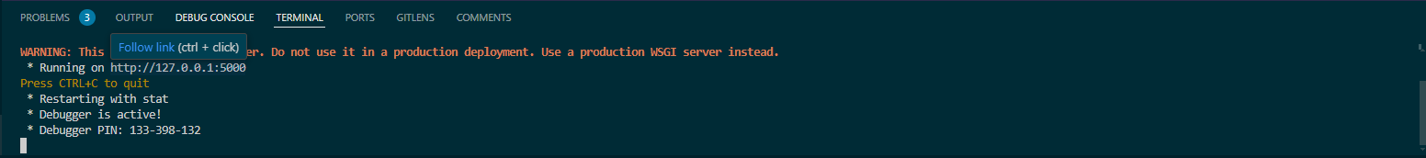

* **Access the application by navigating to http://127.0.0.1:5000/ in your web browser or click with your mouse to ‘Follow link’**
* **After navigating or clicking to link, in your web browser you will direct to the Home Page of website:**

- **Be able to enter/use ‘Create book’ web page or ‘my books’ web page user must have an account!!**

**Directory Structure**

* **app.py:** Main application file
* **static/:** Static files (CSS, images)
* **templates/:** HTML templates (JS files in Html)
* **users.db:** SQLite database file

**Routes**

* **/ -** Home page
* **/login -** Login page
* **/register -** Registration page
* **/about -** About page
* **/create -** Create a new story
* **/books -** View your books
* **/read_book/<int:book_id> -** Read a specific book
* **/logout -** Logout